4.

(a) single core processor, only one process can be run at any point in time, no parallelism

(b) Physical memory can contain any amount of operations, as they are just instructions that are stored in memory, BUT at any one time, a single core processor can only execute one process at any single point. <https://www.guru99.com/paging-in-operating-system.html#:~:text=Paging%20is%20a%20storage%20mechanism,memory%2C%20which%20is%20called%20frames>.

(c) (contiguous is basically continuous) linked lists aren’t continuous. Basically linked lists have 3 main parts: head, body and pointer. The head is the address of the node, the body contains the content, then pointer will point to the next node (head/address of the next node)

5.

(a)

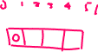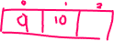

(b) and (c) logic <https://www.geeksforgeeks.org/cache-hits-in-memory-organization/>

(d)

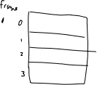

(e)

